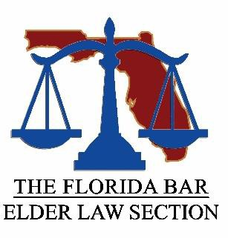
The Florida Bar Elder Law Section
651 East Jefferson Street Tallahassee, FL 32399-2300

Membership Application Form

Applicant Information
Full Name:
Address: | Last | First and M.I. | Bar Number (if applicable)
 | Street Address |  | Apartment/Unit #
Telephone: | City | State | ZIP Code
Email: | Work | Personal (optional)
Membership Type
The practice of Elder Law is constantly changing, and the Elder Law Section of The Florida Bar seeks to keep its members abreast of all the recent developments. Membership in the Section provides access to sponsored continuing legal education programs at a reduced rate, access to section meetings, receive the Section's newsletter, The Advocate, and the Section website at: www.eldersection.org.

Select one of the are three Elder Law Section membership types:
- Membership (member of The Florida Bar) - $50 annual fee (#3001)
- Affiliate Member (i.e., Professional Guardian) - $50 annual fee (#3002)
- Full-time Florida Law Student – Free (#3002)
Method of Payment
- Check enclosed made payable to The Florida Bar (651 E. Jefferson Street, Tallahassee, FL 32399)

- Credit Card (Fax to 850-561-9413; Email to registrations@floridabar.org)

Circle one: MASTERCARD VISA DISCOVER AMEX Exp. Date: ______/______ (MO./YR.) Name: ______________________________________________________________ __ Credit Card #: ________________________________ Billing Zip Code: ___________
Signature: _____________________________________________________________

